**Seminar Report**

**On**

**Organic Light Emitting Diodes (OLEDs)**

**Goundra Amarnath**

**19261A0470**

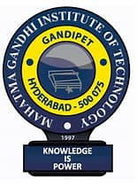

**Department of Electronics and Communication Engineering**

**MAHATMA GANDHI INSTITUTTE OF TECHNOLOGY**

**(Affiliated to Jawaharlal Nehru Technological University, Hyderabad)**

**Chaitanya Bharathi P.O., Gandipet, Hyderabad – 500 075**

**2022 – 2023**

**ORGANIC LIGHT EMITTING LIGHTS**

**(OLEDS)**

**Seminar Report**

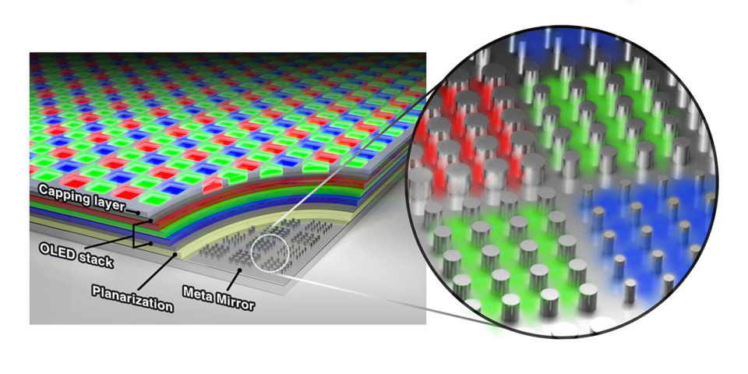

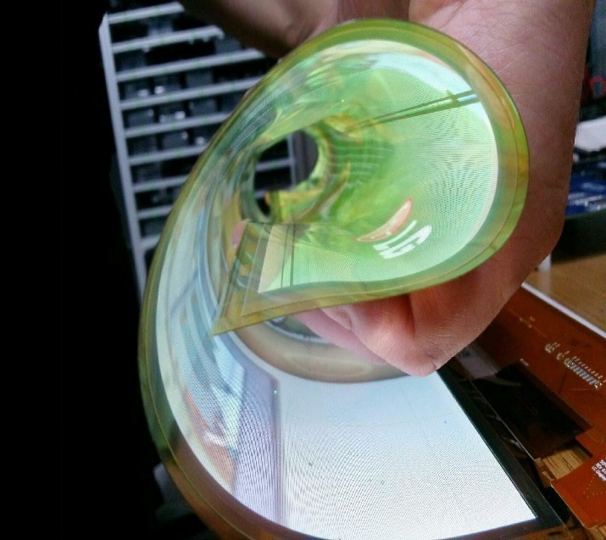 See the source image

**TABLE OF CONTENTS**

**INDEX:**

* **ABSTRACT**
* **INTRODUCTION**
* **HISTORY**
* **HOW DOES A PIXEL CREATE?**
* **PRACTICAL IMAGE REPRODUCTION**
* **LED AND ITS WORKING**
* **What is an LED?**
* **How does an ordinary LED work?**
* **How does an LED display work?**
* **Working**
* **OLED LAYERS**
* **FOLEDs**
* **TOLEDs**
* **WOLEDs**
* **OLED WORKING**
* **How does an OLED work?**
* **ADVANTAGES**
* **DISADVANTAGES**
* **APPLICATIONS**
* **THE ORGANIC FUTURE**
* **CONCLUSION**
* **REFERENCES**

**ABSTRACT**

An organic light emitting diode (OLED) could be a light emitting diode (LED) during which the emissive electroluminescent layer could be a film of organic that emits light in response to an electrical current. This layer of organic semiconductor is set between 2 electrodes a minimum of one among these electrodes is clear. OLEDs square measure wants to produce digital displays in devices like TV screens, pc monitor and transportable system like mobile phones, handheld game console and PDs.

A significant space of analysis is that the development of white OLED devices to be used in solid-state lighting application. An OLED show works while not a backlight; it will show deep black level and might be diluted and lighter than a liquid show (LCD). In low close light weight condition (such as a dark room). An OLED screen is able to do the next distinction quantitative relation than an alphanumeric display in spite of whether or not the alphanumeric uses are cold cathode fluorescent lamp or an LED backlight.

An OLED is an electronic device made by placing a series of organic thin films between two conductors. When electrical current is applied, a bright light is emitted. OLEDs are lightweight, durable, power efficient and ideal for portable applications. OLEDs have fewer process steps and also use both fewer and lower-cost materials than LCD displays. More and more people believe that OLEDs can replace the current technology in many applications.

First part of this seminar is a physical overview of semiconducting properties of organic polymers and takes a deeper insight in their electron structure, pixel, LED basics and LED working. Second part of seminar deals with structural OLED properties and phosphorescence material doping phenomena as improvement of efficiency and working. Then it offers some technical facts, the question of stability of OLEDs and so present and future aspects of use in actual products.

Finally, we look into the advantages, disadvantages, applications and future scope of OLED. This report will give you the overall working, applications of OLED.

**INTRODUCTION**

An OLED is a display technology consisting of OLED panels that emit their own light when an electric current is passed through them. The “organic” in OLED stands for the organic molecules that are used in the OLED panels, as opposed to the inorganic semiconductor materials used in traditional LEDs. OLEDs offer a number of advantages over traditional LEDs, including a wider viewing angle, faster response time, and higher contrast ratio. However, OLEDs are also more expensive and more sensitive to water damage than traditional LEDs.

A decade or two ago, televisions and computer screens used to be big and bulky, due to the CRT technology that was used in them. Then came LCD screens, and the size of electronic displays shrunk dramatically. Next up were LED screens. These were not so different from their predecessors (i.e., LCDs) in terms of appearance (you couldn’t tell an LED from an LCD just by looking at them), but they significantly reduced the electricity consumption of electronic displays (along with a few other differences).

## What is OLED display?

OLED is a relatively new type of display for televisions, smartphones, laptops. After only being invented in 1987, OLED is already one of the two top display technologies in the industry. OLED stands for Organic Light Emitting Diode. This display technology uses organic (carbon-containing) compounds that emit light when a current is passed through it. **OLED technology is known for its high picture quality along with its premium price point**. OLED’s main competitor is the cheaper liquid crystal display, abbreviated LCD. However, OLED boasts higher colour contrast and larger viewing angles which make it ideal for high-end electronics. OLED panels are also lighter and more flexible than LCD displays. They are also long-lasting with a lifespan of around 22 years if used 6 hours a day. There are many different types of OLED displays. The most common types are [Passive-Matrix OLED (PMOLED)](https://www.orientdisplay.com/oled-displays/) and Active-Matrix OLED (AMOLED). The main difference between these two is that the active-matrix OLED has a thin film transistor (TFT) while passive matrix OLEDs do not. Thin film transistors act as semiconductors in OLED displays. AMOLED is best used for large-sized screens because the TFTs make it more energy efficient. Another type of OLED is the phosphorescent OLED or PMOLED. **Phosphorescent OLEDs are more efficient than fluorescent OLEDs**. The high-efficiency phosphorescent OLEDs lose energy slower by fading gradually instead of disappearing right away. There is also another type of OLED often called PLED that uses light-emitting polymers instead of organic molecules. Most OLEDs have glass substrates, but **OLED devices can also be made with plastic substrates ideal for flexible OLEDs** because they are thinner.

## What does OLED stand for?

OLED stands for Organic Light Emitting Diode. In this case, organic does not refer to food but to its chemistry definition: molecules that consist of chains or rings of carbon along with other elements. The rest of the acronym, LED, stands for Light Emitting Diode. This refers to any system with two electrodes that emits light in the presence of an electrical current. The electrodes are of opposite charges. The positively charged electrode is called the cathode while the negatively charged electrode is the anode. In between the electrodes are the organic layers. Therefore, when the electrons go from the anode to the cathode creating a current, they pass through the organic materials which then emit coloured light.**OLED displays use yellow and blue organic materials**. Other colours are then made using many colour filters.

## HISTORY

## Who invented OLEDs?

Organic semiconductors were discovered in the mid-1970s by Alan Heeger, Alan MacDiarmid, and Hideki Shirakawa, who shared the [Nobel Prize in Chemistry in 2000](https://www.nobelprize.org/nobel_prizes/chemistry/laureates/2000/popular.html) for their work. The first efficient OLED—described as "a novel electroluminescent device... constructed using organic materials as the emitting elements"—was developed by Ching Tang and Steven VanSlyke, then working in the research labs at Eastman Kodak, in 1987. Their work, though novel, built on earlier research into electroluminescence, which was [first reported in organic molecules](https://iopscience.iop.org/article/10.1088/0508-3443/6/S4/319) by a French physicist named André Bernanose in 1955. He and his colleagues applied high-voltage AC (alternating current) electric fields to thin films of cellulose and cellophane "doped" with acridine orange (a fluorescent, organic dye) and carbazole. By 1970, Digby Williams and Martin Schadt had managed to [create what they called "a simple organic electroluminescent diode" using anthracene](https://ieeexplore.ieee.org/document/1449585), but it wasn't until [Tang and VanSlyke's work](https://aip.scitation.org/doi/10.1063/1.98799), in the 1980s, that OLED technology became truly practical.

Milestones in the development of OLEDs since then have included the first commercial OLED (Pioneer, 1997), the first full-sized OLED display (Sony, 2001), the first OLED mobile phone display (Samsung, 2007), commercial OLED lighting systems (Lumiotec, 2013), and large-screen commercial OLED TVs (by Samsung, LG, Panasonic, Sony, and others in 2012 and 2013). [[1]](https://www.explainthatstuff.com/how-oleds-and-leps-work.html" \l "1fn) In 2020, Chinese manufacturer TCL [announced](https://www.oled-info.com/tcl-aims-start-producing-inkjet-printed-oled-tvs-its-85-gen-line-guangzhou-2024) it would invest almost $7 billion in a new method of making OLEDs using a technology similar to [inkjet printing](https://www.explainthatstuff.com/inkjetprinters.html), with the [promise](https://www.techradar.com/uk/news/tcl-oled-tvs-could-see-the-technology-finally-become-affordable) of producing cheaper OLED products by 2023.

## How does a Pixel create?

Interestingly, the fundamental image reproduction mechanism is the same in all the display technologies. The smallest display unit is an element called a pixel; You can see in the Fig, three different colour filters inside a pixel. The most amazing thing is that we can achieve any colour just by illuminating these filters at different intensities. I have shown in the Fig below. Now, you might doubt that the filters are different pieces; how can these three different colours get mixed up and produce a new colour (Fig:)?

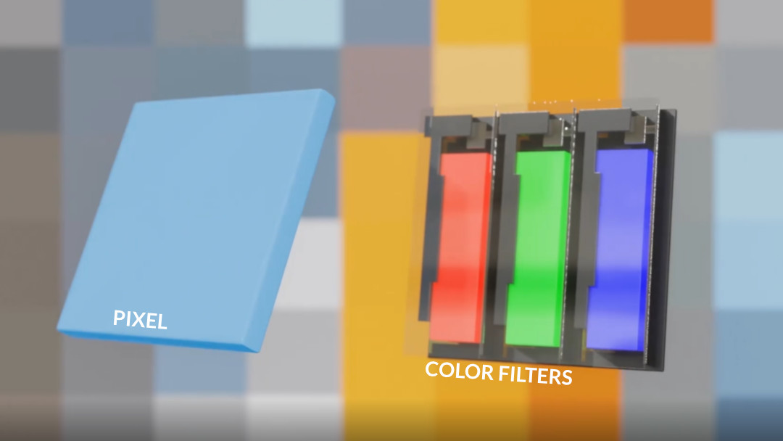Fig: - Colour filters inside pixel

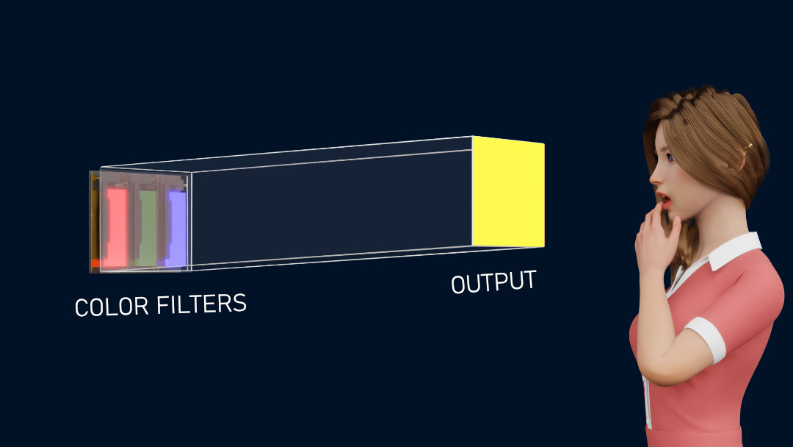Fig: -Combination of RGB colours produced new colour

I will explain this phenomenon with a simple example. We can see that the colours are distinctive! After a certain pixel size, the individual colours are not distinguishable. You will see the combined colour of all. This is due to the limited visual resolution of the human eye; it can’t differentiate between subpixels.

**Practical image reproduction**

Now, let’s convert these pixels into digital, so each pixel has its position and colour data. This data is stored in digital form for future reproduction of the image. Now, let’s see how image reproduction is done practically. I took a uniform white backlight source, and kept a colour filter containing multiple small red, blue, and green colours in front of it; again, placed a glass screen in front of it. As soon as I turn on the backlight, all the filters will glow with equal intensity and what we get at the output is just white colour as you can see in Fig.

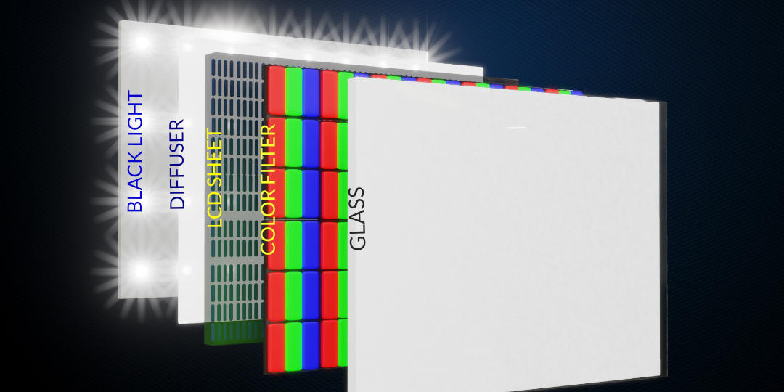Fig:-Image reproduction setup

**LED**

## What is an LED?

LEDs (light-emitting diodes) are the tiny, coloured, indicator lights you see on electronic instrument panels. They're much smaller, more [energy](https://www.explainthatstuff.com/energy.html)-efficient, and more reliable than old-style [incandescent lamps](https://www.explainthatstuff.com/incandescentlamp.html). Instead of making [light](https://www.explainthatstuff.com/light.html) by heating a wire filament till it glows white hot (which is how a normal lamp works), they give off light when electrons zap through the specially treated ("doped") solid materials from which they're made.

An OLED is simply an LED where the light is produced ("emitted") by organic molecules. When people talk about [organic](https://www.explainthatstuff.com/organic-farming.html) things these days, they're usually referring to food and clothing produced in an environmentally friendly way without the use of pesticides. But when it comes to the chemistry of how molecules are made, the word has a completely different meaning. Organic molecules are simply ones based around lines or rings of carbon [atoms](https://www.explainthatstuff.com/atoms.html), including such common things as sugar, gasoline, alcohol, [wood](https://www.explainthatstuff.com/wood.html), and [plastics](https://www.explainthatstuff.com/plastics.html).

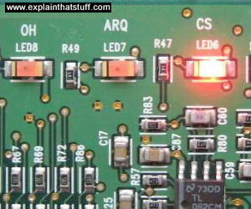

Photo: LEDs on an electronic instrument panel. They make light by the controlled movement of electrons, not by heating up a wire filament. That's why LEDs use much less energy than conventional lamps.

## How does an ordinary LED work?

Before you can understand an OLED, it helps if you understand how a conventional LED works—so here's a quick recap. Take two slabs of semiconductor material (something like silicon or germanium), one slightly rich in electrons (called n-type) and one slightly poor in electrons (if you prefer, that's the same as saying it's rich in "holes" where electrons should be, which is called p-type). Join the n-type and p-type slabs together and, where they meet, you get a kind of neutral, no-man's land forming at the junction where surplus electrons and holes cross over and cancel one another out. Now connect electrical contacts to the two slabs and switch on the power. If you wire the contacts one way, electrons flow across the junction from the rich side to the poor, while holes flow the other way, and a current flow across the junction and through your circuit. Wire the contacts the other way and the electrons and holes won't cross over; no current flows at all. What you've made here is called a junction diode: an electronic one-way-street that allows current to flow in one direction only. We explain all this more clearly and in much more detail in our main article on [diodes](https://www.explainthatstuff.com/diodes.html).

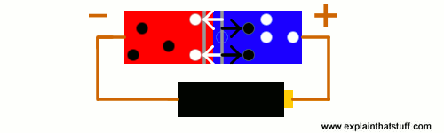

Artwork: A junction diode allows current to flow when electrons (black dots) and holes (white dots) move across the boundary between n-type (red) and p-type (blue) semiconductor material.

An LED is a junction diode with an added feature: it makes light. Every time electrons cross the junction, they nip into holes on the other side, release surplus energy, and give off a quick flash of light. All those flashes produce the dull, continuous glow for which LEDs are famous.

**HOW DOES AN LED DISPLAY WORK?**

To have a better understanding of [OLED TV](https://www.reliancedigital.in/search?q=OLED%20TV:relevance)s, let us first understand how pictures are created on a [LED TV](https://www.reliancedigital.in/televisions/c/S101812#searchQuery=:relevance:availability:Exclude%20out%20of%20Stock&page=0). An LED TV is made of three main components – LED backlit diodes, liquid crystals and colour filters. When we turn on our TV, these diodes gets electrically charged and produce light. This light then passes through liquid crystals layer and a RGB colour filter. A RGB colour filter is made of small individual colour pixels which are capable of reproducing colours and that’s how we see pictures on our screen.

Some of us may have this question – if we are talking about an LED TV, why does it have a liquid crystal panel in it? This confusion is because of the terms used to describe these technologies. Whenever we watch a LED TV, we actually see a LCD display which gets its light from LED diodes. So the term [LED TV](https://www.reliancedigital.in/televisions/c/S101812#searchQuery=:relevance:availability:Exclude%20out%20of%20Stock&page=0), just refers to the LED diodes which produce light and not the display.

As of now, there are three main types of backlit technologies – an edge-lit technology which is used in most of the LED TVs, PC monitors and phones, while the most premium among them is the full-array technology, which is used in high-end full HD TVs.

**WORKING**

Now to get the other colours, I just need to get different brightness levels for the sub-pixels. To do this, I will use an LCD sheet and a small circuit. The polarisation of the LCD crystal can be adjusted, and we will easily get different brightness levels in the subpixels (Fig). Now, it's time to convert the digital signal we stored to electrical signals. These electrical signals are fed into the circuit. When the signal is received, the crystal in the LCD rotates and polarises the light. In this way, we successfully produced our original image (Fig).

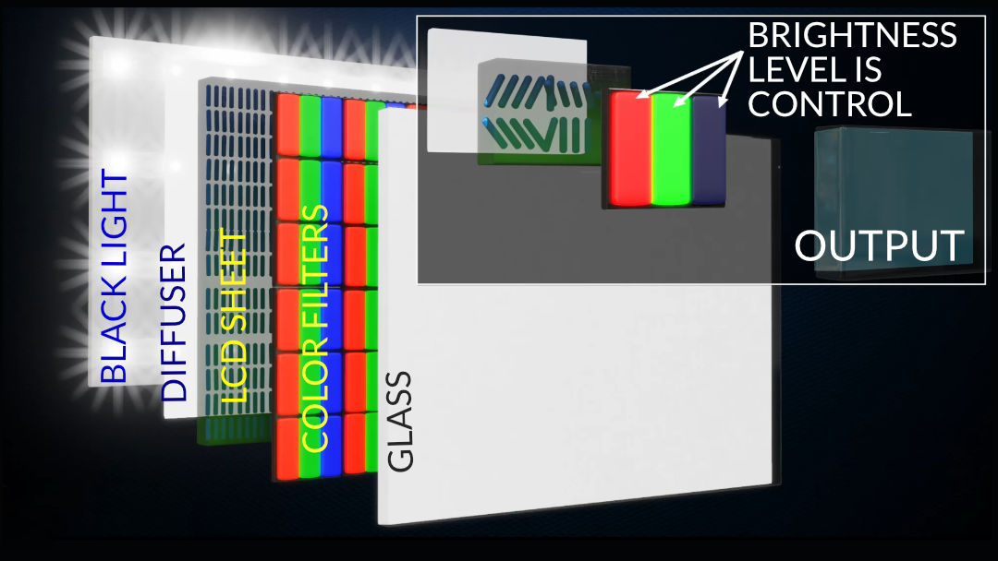Fig: - To get different colours, polarisation of the LCD crystal adjusted

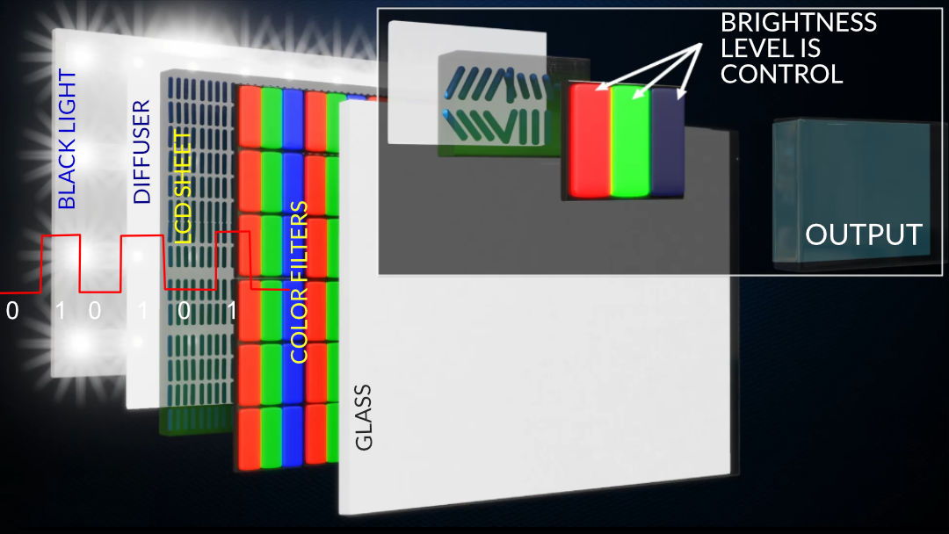Fig:- LCD’s crystal rotates by receiving the  
electric signal and light has been polarised

There are several disadvantages of this display technology! The colour reproduction is not that accurate. For example, when we try to produce a perfect black colour using this technology, this is what we get. The energy consumption in those display types is quite high. What if we provide each pixel with its light source and control it?

This is a great idea. Instead of using a common light source, use minute and many light sources for every pixel. With this method, the LCD sheet can also be removed. However, the issue is that fabrication of such minute LEDs in the range of micrometres is not practical. Due to the issue of surface irregularities and their solid nature at room temperature, they cannot be miniaturised into micrometre ranges. This is why organic LED comes into the picture. They can be fabricated as small as 6.3 micrometres. Now I will explain it below in detail.

**An OLED display have the following**[**advantages over an LCD display**](https://www.oled-info.com/oled-vs-led)**:**

* Improved image quality - better contrast, higher brightness, fuller viewing angle, a wider colour range and much faster refresh rates.
* Lower power consumption.
* Simpler design that enables ultra-thin, flexible, foldable and transparent displays
* Better durability - OLEDs are very durable and can operate in a broader temperature range

**OLEDS**

**LAYERS OF OLED**

Organic light emitting diodes (devices) or OLEDs are monolithic, solid-state devices that typically consist of a series of organic thin films sandwiched between two thin-film conductive electrodes. When electricity is applied to an OLED, under the influence of an electrical field, charge carriers (holes and electrons) migrate from the electrodes into the organic thin films until they recombine in the emissive zone forming excitons. Once formed, these excitons, or excited states, relax to a lower energy level by giving off light (electroluminescence) and/or unwanted heat.

The basic OLED cell structure consists of a stack of thin organic layers sandwiched between a conducting anode and a conducting cathode. Breakdown of an OLED structure:

* Substrate (can be plastic, glass, or metal foil) – Foundation of the OLED
* Anode (may or may not be transparent depending on the type of OLED) – Positively charged to injects holes (absence of electrons) into the organic layers that make up the OLED device
* Hole Injection Layer (HIL) – Deposited on top of the anode this layer receives holes from the anode and injects them deeper into the device
* Hole Transport Layer (HTL) – This layer supports the transport of holes across it so they can reach the emissive layer
* Emissive Layer – The heart of the device and where light is made, the emissive layer consists of a colour defining emitter doped into a host. This is the layer where the electrical energy is directly converted into light.
* Blocking layer (BL) – Commonly used to improve OLED technology by confining electrons (charge carriers) to the emissive layer
* Electron Transport Layer (ETL) – Supports the transport of electrons across it so they can reach the emissive layer.
* Cathode (may or may not be transparent depending on the type of OLED) – Negatively charged to inject electrons into the organic layers that make up the OLED device.

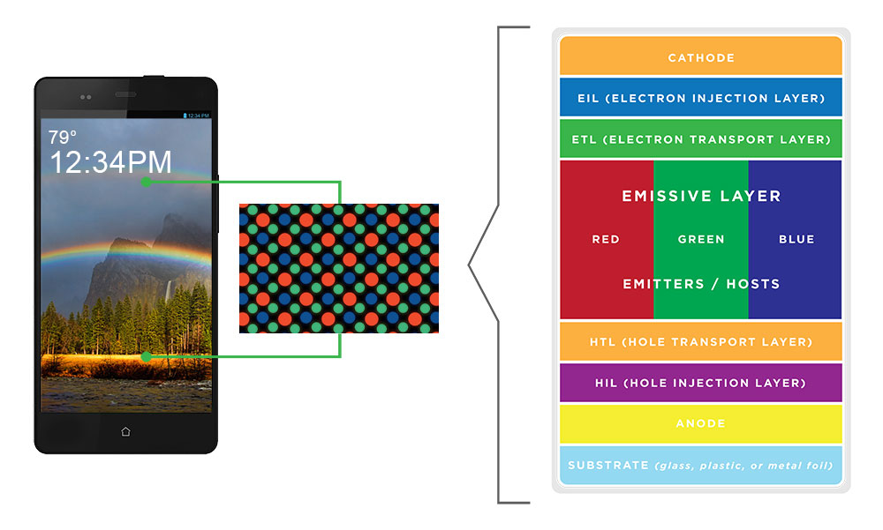

## Flexible OLEDs (FOLEDs)

One of the many benefits of OLEDs includes its manufacturability on rigid (glass) or flexible substrates. We are working on a number of technologies required for the fabrication of OLEDs on flexible substrates or FOLEDs. FOLEDs are OLEDs built on non-rigid substrates such as plastic or metal foil. This enhances the durability and enables conformation to certain shapes and even repeated bending, rolling or flexing. FOLEDs, still in their infancy, will usher in a range of new design possibilities for the display and lighting industries. Imagine having a mobile phone that looks like a pen but has a bright, full-colour display that rolls in and out for use. We call that the Universal Communication Device™ (UCD). Open your imagination to what consumer and lighting products can be, including a foldable smartphone that could open up into a tablet display, a television that could roll up into your pocket, and conformable transparent interior lighting panels that could be unbreakable. These ideas offer, we believe, a mere glimpse into the wonders and possibilities that FOLEDs engender.

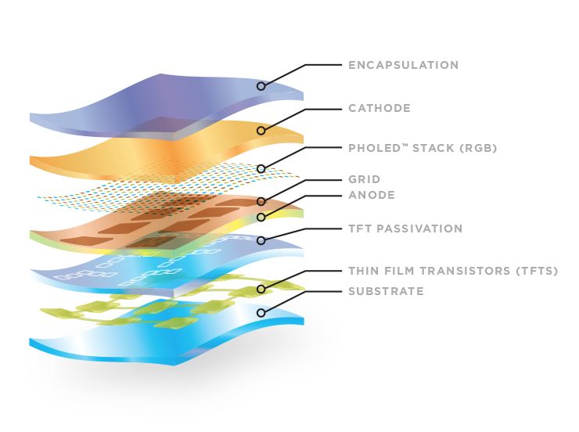

**Transparent OLEDs (TOLEDs)**

The first OLED devices were constructed with a metallic cathode, so the light generated in the device exited through the glass substrate (i.e. the anode side of the device). With the invention and development of a transparent cathode, the light can exit through both sides of the device. In addition, when the device is turned off, the device can be transparent.

Transparent OLED (TOLED) technology enables three key features that have the potential to create a host of new product opportunities.

* Top emission
* Transparency
* Stacking

Universal Display’s TOLED® technology is based on a proprietary top contact, or cathode, that is optically transparent. In Figure A below, you see typical OLED, where the bottom contact, or anode, consists of a transparent metal oxide film and the top contact consists of a reflective metal. As a result, when light is generated by the OLED, it emits through the bottom transparent surface. TOLEDs, as shown in Figure B, use an optically transparent top cathode, meaning both top and bottom contacts allow light transmission.

With the same proprietary cathode that is used for transparent OLEDs, TOLED technology can be employed for use in top-emitting OLEDs. In a top emission OLED, as shown in Figure C, the anode and cathode work together to form an optical cavity, emitting light away from the substrate and the backplane, increasing the aperture ratio of the display. This is very good for mobile devices and screens where you can turn the display to ensure the best viewing angle, as it increases the light output and increases display efficiency at normal viewing angles.

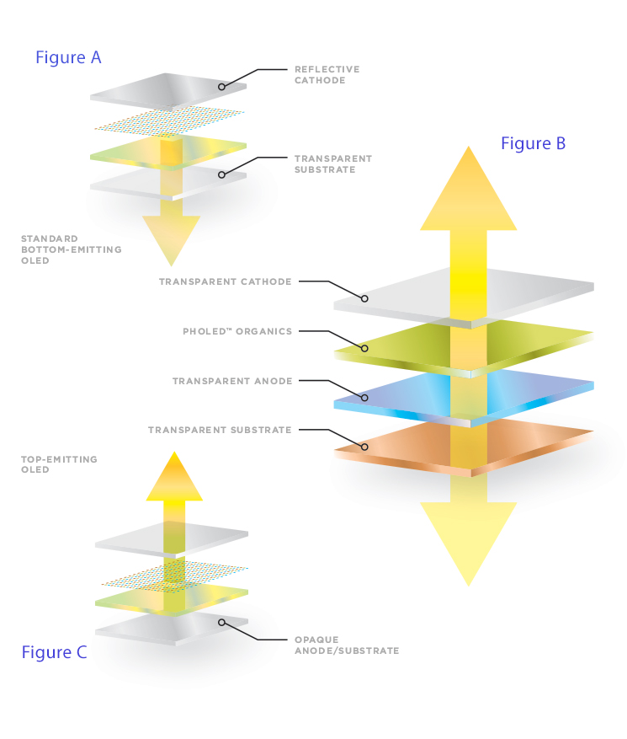

## White OLEDs (WOLEDs)

White OLEDs have the potential to offer significant performance advances to the general lighting arena. Since Edison’s development in 1879, its energy efficiency of the incandescent light bulb has not improved beyond 4% — equivalent to about 12 lumens/Watt (lm/W). Consequently, incandescent light bulbs are losing favour here in the U.S. and around the world. In fact, plans are underway to ban and/or phase them out altogether. Fluorescent tubes, capable of up to 120 lm/W, but typically in the 70-100 lm/W range, offer colour qualities that are undesirable for many applications. They also present numerous environmental and disposal issues because they contain mercury. Universal WOLED ™ OLED lighting has the potential to reach more than 150 lm/W. We believe that OLEDs offer significant energy savings and environmental benefits to end users around the world. With lighting accounting for 15% of global electricity consumption and 5% of worldwide greenhouse gas emissions, WOLEDs could have real impact on reducing energy consumption.

In the solid-state lighting realm, OLEDs and LEDs are complementary. OLEDs are excellent surface lights, while LEDs are bright point light sources. As noted by the U.S. DOE, OLEDs can be configured as larger-area, more diffuse light sources, which may be more practical for general ambient lighting because the soft light can be viewed directly, with less need for shades, diffusers, lenses, louvers, or parabolic shells. Since OLEDs can be very thin, they are more appealing, and can easily attach to wall surfaces and ceilings. This, coupled with the diffuse nature of OLED lighting, can enable an entirely new type of light and light fixture that’s both attractive and highly efficient. OLEDs can also be made in almost any shape, can be deposited on flexible substrates, and can be transparent, emitting light from both sides of the device—features that greatly expand the design possibilities, allowing for a completely new lighting experience.

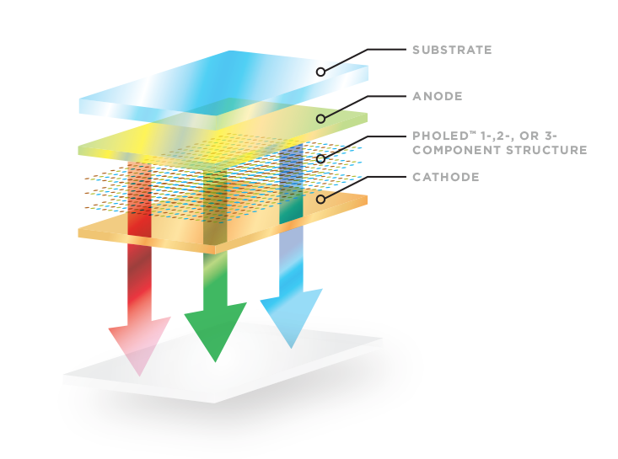

## How does an OLED work?

OLEDs work in a similar way to conventional diodes and LEDs, but instead of using layers of n-type and p-type semiconductors, they use organic molecules to produce their electrons and holes. A simple OLED is made up of six different layers. On the top and bottom there are layers of protective [glass](https://www.explainthatstuff.com/glass.html) or [plastic](https://www.explainthatstuff.com/plastics.html). The top layer is called the seal and the bottom layer the substrate. In between those layers, there's a negative terminal (sometimes called the cathode) and a positive terminal (called the anode). Finally, in between the anode and cathode are two layers made from organic molecules called the emissive layer (where the light is produced, which is next to the cathode) and the conductive layer (next to the anode).

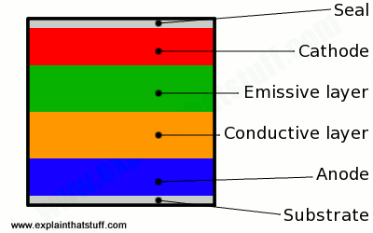

The arrangement of layers in a simple OLED.

**How an OLED emits light**

**How does this sandwich of layers make light?**

1. To make an OLED light up, we simply attach a voltage (potential difference) across the anode and cathode.

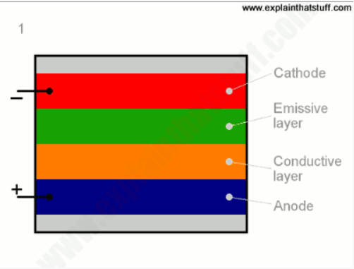

1. As the [electricity](https://www.explainthatstuff.com/electricity.html) starts to flow, the cathode receives electrons from the power source and the anode loses them (or it "receives holes," if you prefer to look at it that way).

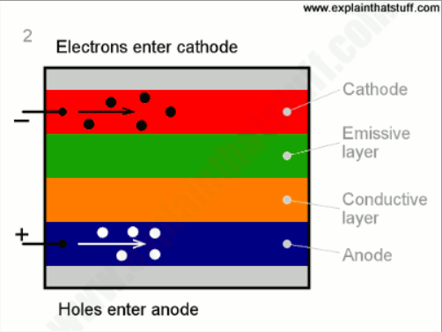

1. Now we have a situation where the added electrons are making the emissive layer negatively charged (similar to the n-type layer in a junction diode), while the conductive layer is becoming positively charged (similar to p-type material).

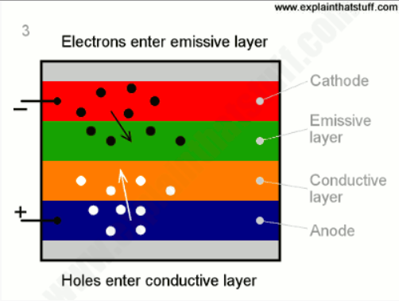

1. Positive holes are much more mobile than negative electrons so they jump across the boundary from the conductive layer to the emissive layer. When a hole (a lack of electron) meets an electron, the two things cancel out and release a brief burst of energy in the form of a particle of light—a photon, in other words. This process is called recombination, and because it's happening many times a second the OLED produces continuous light for as long as the current keeps flowing.

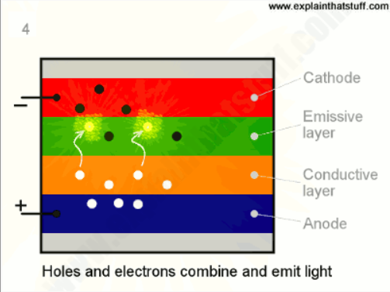

We can make an OLED produce coloured light by adding a coloured filter into our plastic sandwich just beneath the glass or plastic top or bottom layer. If we put thousands of red, green, and blue OLEDs next to one another and switch them on and off independently, they work like the pixels in a conventional LCD screen, so we can produce complex, hi-resolution-coloured pictures.

We control each subpixel independently just by varying the external power supply we can control the electron flow or recombination rate and reproduce any image. It is quite obvious that black colour reproduction can be perfectly achieved using this technology.

The current OLEDs produce only white light a cool and promising future of OLED technology is that we can even avoid the usage of colour filters with its help.

What if we directly obtain RGB colour light emission from the OLED source itself this is certainly a possibility currently various OLED manufacturing companies are working on developing RGB colour emitting OLED devices by adding various doping materials in emission layers due to the addition of doping material the band gap of an emissive layer is changed accordingly changing the colour of light emission.

**ADVANTAGES**

#### **Higher contrast levels**

An OLED display can produce significantly high contrast levels compared to a LED display. As an OLED display can individually control its pixels, these pixels can completely turnoff themselves whenever they are required to produce absolutely dark blacks. Hence, the pictures produced on an [OLED TV](https://www.reliancedigital.in/search?q=OLED%20TV:relevance) have a deep vibrant colour unlike any other television. A typical LED TV cannot achieve such darks, as the backlit LED diodes are only capable of dimming themselves, not turning off entirely.

#### **100% Live Pixel**

Get accurate image quality and exceptional colour with ‘100% Live Pixel’ control. Do you still have a TV with a backlight that ruins the image? OLED has no image distortion because its millions of pixels all light up on their own for perfect colour and contrast control. Only TVs with OLED can deliver truly detailed images without exaggeration or quality loss.

#### **100% Colour Fidelity**

See it all exactly how the creators intended with ‘100% Colour Fidelity’. All TVs claim to have improved colour, but only OLED TV allows you to experience 100% perfect colour accuracy. Check to make sure you have an OLED TV to get natural colours and see everything the way creators intended.

#### **Wide viewing angles**

If you have an [OLED TV](https://www.reliancedigital.in/search?q=OLED%20TV:relevance), you can easily watch content from any corner of your home without losing out on colour accuracy. As an OLED TV has a compact build, the distance between pixels and the surface of the screen is nearly non-existent. Hence, the pictures produced on an OLED TV have better viewing angles.

In case of an LED TV, viewing angles largely depends on the type of technology being used. Most entry-level PC monitors and phones use basic twisted nematic (TN) panel, which generally offer poor viewing angles. Fortunately, the majority of LED TVs and smartphones today sport IPS panels which are capable of delivering good viewing angle.

#### **Thinner and flexible**

An OLED display retains some special properties, which makes them thin as well as flexible. TV manufacturers have already experimented with curved [OLED TV](https://www.reliancedigital.in/search?q=OLED%20TV:relevance)s. In fact, smartphone manufacturers have made phones with curved displays which created a buzz in the market for a while. Brands such as LG has been doing wonderful work in development of the flexible OLED display technologies. LG already launched their wallpaper OLED series TVs which sticks to your wall using magnets. At CES 2019, LG even announced their 65-inch Signature OLED TV which can change its height, roll down to show information like weather or even completely roll into its stand and disappear. Could this be the future of OLED TVs in our homes? Time will tell.

**Lighter weight**

Built on very thin plastic or metal foil, FOLEDs can be much thinner and lighter than backlit LCDs and other displays in the market today. So cell phones, portable computers, wall-mounted televisions and other products with displays, can also be lighter and smaller. Plus, FOLED technology may allow easier installation of white OLED lighting tiles in more settings, and create novel uses in architecture that are not possible with today’s fluorescent and incandescent lights.

**More durable, safer and impact resistant**

Glass breakage is a major issue of display-containing products and a key safety concern in the lighting field. Plastic and metal-based FOLEDs essentially eliminate these issues, creating obvious advantages in both displays and lighting.

**Cost-effective**

Today, OLEDs typically use production techniques that rely on the sequential processing of discrete glass panels. With flexible substrates that typically originate in a roll-stock format (like paper rolls), it is envisioned that FOLED production may evolve to higher throughput, roll-to-roll processes, as commonly used in the printing industry. This may provide the basis for truly low-cost mass production.

**Transparency**

Capable of 70% to 85% transparency when turned off, TOLED pixels are nearly as clear as the glass or plastic substrate on which they are built. When used in an active-matrix OLED configuration, the effective transmission of a TOLED display may, however, be somewhat reduced depending on the resolution of the display and TFT design.

**Bi-directional emission**

Typically, the light generated by the TOLED emits from both surfaces. Enhancement films and other optical treatments may be used to direct more of the light in one direction than the other.

**Performance**

TOLEDs also offer excellent opto-electronic performance properties, i.e., spectral colour emission, luminous efficiency and lifetime – that compare well to those for bottom-emission OLEDs.

#### **Low Blue Light**

Relieve eye strain with ‘Low Blue Light’ that doesn’t interfere with your sleep.

#### **Flicker Free**

‘Flicker Free’ doesn't burden your eyes because it doesn't even blink. A display that minimizes eye fatigue by eliminating even blinking phenomena that cannot be detected with the naked eye. For your family's eye health, choose OLED.

**Stacking**

Fabricating one OLED on top of another OLED can be advantageous in terms of improving overall lifetime and also providing a broader range of output colour spectrum.

### **Automotive**

As interest in future automobile markets such as electric vehicles and autonomous vehicles increases, vehicle displays are also attracting attention. As automobiles transform from a simple means of transportation to a space that provides users with valuable time, the level of information and entertainment provided to them is also increasing. The types and quantity of displays mounted on vehicles are also gradually increasing.

In-vehicle displays should not only have a high degree of design freedom, but also have high visibility so that the screen can be viewed well even under strong sunlight. It must also provide fast response speed and accurate information, regardless of temperature. LCDs have slow screen response at low temperatures, so screen switching is slow, but OLEDs show quick response regardless of the weather. In addition, it can be applied to various designs through excellent outdoor visibility and Flexible OLED, which is advantageous for automotive displays.

#### **Higher Recyclability**

Eco-friendly displays with ‘Higher Recyclability’ leave less trash on our planet. Between a TV that pollutes with excessive parts, or a TV that reduces unnecessary plastics and offers the best performance, which would you choose? OLED enables the thinnest and most beautiful TVs in the world with minimal plastic and waste.

**DISADVANTAGES**

OLEDs aren't perfect. First of all, it costs more to produce an OLED than it does to produce an LCD - although this should hopefully change in the future, as OLEDs has a potential to be even cheaper than LCDs because of their simple design (some believe that [future OLEDs will be printed using simple ink-jet processes](https://www.oled-info.com/oled-inkjet-printing)).

OLEDs have limited lifetime (like any display, really), that was quite a problem a few years ago. But there has been constant progress, and today this is almost a non-issue. Today OLEDs last long enough to be used in mobile devices and TVs. OLEDs can also be [problematic in direct sunlight](https://www.oled-info.com/oleds-direct-sunlight), because of their emissive nature. But companies are working to make it better, and newer AMOLEDs (such as Samsung's [Super AMOLED](https://www.oled-info.com/super-amoled) and [Super AMOLED Plus](https://www.oled-info.com/super-amoled-plus) and Nokia's [CBD displays](https://www.oled-info.com/nokia-clearblack-display-cbd)) are quite good in that respect - some even consider them superior to LCDs.

## Applications

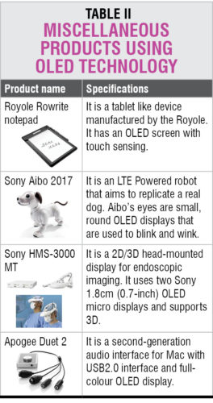OLED displays are mainly used in digital devices such as high-end television systems, computer monitors, pocket-size systems such as Android phones, media players, digital cameras, portable gaming consoles and mini-screens. Such types of applications demand high reliability and readability. OLEDs fit in as these consume less power and provide high-quality display. The current OLED technology provides remarkable colour fidelity, high efficiency and operation stability. Products available across different categories are listed below.

### **Mobile phones**

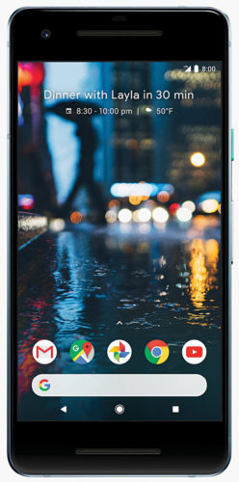

Fig.: Google Pixel 2 OLED display

Since year 2016 many mobile phones have been introduced with OLED screen, including Samsung A8+, Gionee S11S and M7 plus, Oppo A79 and R11 plus, OnePlus 5T, Google Pixel 2 and iPhone X.

### **OLED TV**

TV display technology has evolved from LED to OLED and QLED. At present, all companies are working on OLED displays to make their products smart. OLED TV models include B&O BeoVision Eclipse, Loewe Bild 4, Bild 5 and Bild 9, Toshiba X97, Skyworth W9 Wallpaper OLED and S9E, Panasonic EZ950 and EZ1000, Sony XBR-A1E Bravia and Signage 65EE5PC. Some of the companies like LG have even categorised their TV displays into flat OLED display, curved OLED display and OLED wallpaper.

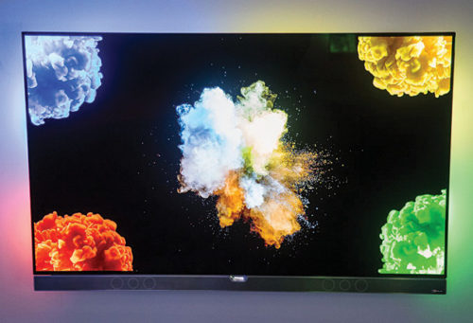

Fig.: An OLED TV set

### **Digital cameras**

Use of OLED displays in digital camera screens or electronic viewfinders is on the rise. The first OLED camera was Kodak LS633 in 2003. Today, there are a host of OLED models available like Canon Power Shot G1 X Mark III, Fujifilm GFX 50S and X-T2, Sony a99 Mark II and HX80, Panasonic DMC-FZ2500 and Lumix DMC-G85, and Nikon DL24-500, DL18-50 and DL24-85.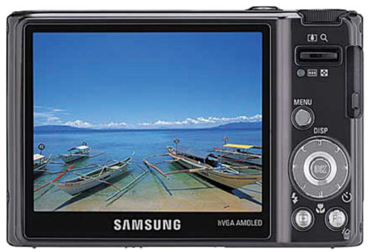

Fig.: Digital camera with OLED screen

### **Wearable devices**

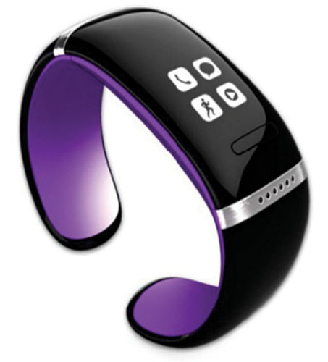

Fig.: OLED screen on wearable watch

Wearable devices include multi-purpose tools that use advanced sensing technologies such as voice command recognition, gesture recognition, and face and fingerprint recognition. OLED technology brings advantages of thinner and curved display form factor to wearable devices. Some of the wearable devices with OLED screens are Xiaomi Mi Band 2, MIO Slice, KIGO Watch, STARVR, Fitbit Alta, I Fit Vue, Mykronoz Zefit2 Pulse and Zefit2, Moto 360 Sport, Asus Zenwatch 2, HTC Vive, Sony PlayStation VR, Razer OSVR, Garmin Vivosmart, and Huawei Talk band B1 and Talk band B2.

### **OLED light panels**

OLED technology enables large-area light panels. OLED displays can be used to make flexible, transparent and colour-tannable light panels. OLED panels emit diffused light, which is very close to natural sunlight. OLED light panels from various companies include IKEA Vitsand, SKK Gooseneck, Ascend, Acuity Brands Olessence and Nomi, Worksite Ergonomics Natural OLED, Bernd Unrecht Adjust-S, Pugnale and Nylene Volker OLED Luminaire, and OTI Aerolite OLED. There are light panels available from LG, Philips, Osram and Konica Minolta too.

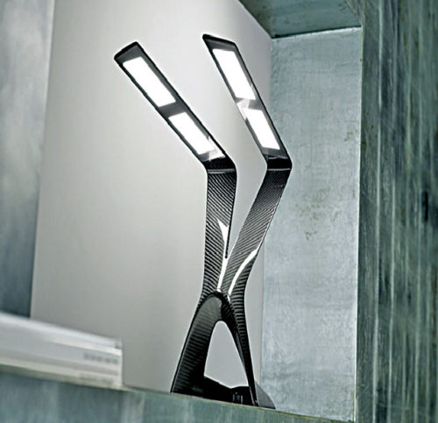

Fig.: An OLED desk lamp

**THE ORGANIC FUTURE**

The first products using organic displays are already being introduced into the market place. And while it is always difficult to predict when and what future products will be introduced, many manufacturers are now working to introduce cell phones and personal digital assistants with OLED displays within the next one or two years. The ultimate goal of using high-efficiency, phosphorescent, flexible OLED displays in lap top computers and even for home video applications may be no more than a few years into future.

However, there remains much to be done if organics are to establish a foothold in the display market. Achieving higher efficiencies, lower operating voltages, and lower device life times are all challenges still to be met. But, given the aggressive worldwide efforts in this area, emissive organic thin films have an excellent chance of becoming the technology of choice for the next generation of high-resolution, high-efficiency flat panel displays.

In addition to displays, there are many other opportunities for application of organic thin-film semiconductors, but to date these have remained largely untapped. Recent results in organic electronic technology that may soon find commercial outlets in display black planes and other low-cost electronics.

**CONCLUSION**

Organic light emitting diode induces electronic viewing more convenient as they are more energy efficient. OLED is so revolutionary that in the field of elucidation it is being hailed as the first discovery since Edison. Today OLED technology is extensively seen as a next generation component for flat panel displays and is expected to become a key technology in the development of flexible displays. They are thinner and more flexible than the crystalline layers in an LED or LCD. They have large fields of view as they induced their own light.

The future prospect looks bright for OLED flat panel displays. OLED displays have been used in aftermarket car audio for the last several years. They are starting to find use in cell phones as secondary displays and are expected to enter the market this year in the form of full colour displays for cell phones. Many industry analysts predict OLED displays for laptops and computer monitors will start to enter the market as soon as 2006. Other applications, such as flexible displays for outdoor advertising signage and billboards, are further out in time. This application requires over 50 times performance improvement in OLED materials in brightness and lifetime, and also requires a complex active-matrix drive scheme, inkjet deposition for low-cost manufacturing, and flexible substrates. Therefore, given the requirements and capabilities of billboard application, it may not be realized within the next five years. Another advanced application for OLED materials includes replacement for fluorescent room lighting, which again depends upon substantial improvement in the performance of materials, in particular, energy efficiency. Meanwhile, in the short term, OLED displays have started and will continue to penetrate the $30 billion dollar display market and have begun to realize their bright future ahead.

**REFERENCES**

* [https://OLED.com/OLEDs/](https://oled.com/oleds/)
* [https://www.reliancedigital.in/solutionbox/how-OLED-technology-works/](https://www.reliancedigital.in/solutionbox/how-oled-technology-works/)
* [https://www.OLED-info.com/OLED-introduction](https://www.oled-info.com/oled-introduction)
* [https://www.energy.gov/eere/ssl/OLED-basics](https://www.energy.gov/eere/ssl/oled-basics)
* [https://www.explainthatstuff.com/how-OLEDs-and-leps-work.html](https://www.explainthatstuff.com/how-oleds-and-leps-work.html)
* [https://www.samsungdisplay.com/eng/tech/OLED-display.jsp](http:// https:/www.samsungdisplay.com/eng/tech/oled-display.jsp)
* [https://www.OLEDspace.com/en/about-OLED/why-OLED/](https://www.oledspace.com/en/about-oled/why-oled/)
* [https://www.orientdisplay.com/knowledge-base/OLED-basics/OLED-history/](https://www.orientdisplay.com/knowledge-base/oled-basics/oled-history/)
* [https://www.kanekaOLED.jp/en/OLED/feature.html](https://www.kanekaoled.jp/en/oled/feature.html)
* [https://www.scienceabc.com/innovation/what-is-OLED-and-how-does-it-work.html](https://www.scienceabc.com/innovation/what-is-oled-and-how-does-it-work.html)
* [https://www.lesics.com/how-does-OLED-display-technology-work.html](https://www.lesics.com/how-does-oled-display-technology-work.html)